*Defines model parameters and cost functions, uses one-way and two-way data tables, Excel Solver, what-if analysis, and monte-carlo simulations with triangularly distributed variables*

**Project**

**4**

P4

ALY6050 Intro to Enterprise Analytics

Project 4 – A Prescriptive Model for Strategic Decision-making, An Inventory Management Decision Model

**PREPERATION:**

By: John DiSessa

For: Professor Behboudi

On: March 20th, 2022

Introduction

The analysis below is to be presented to the Vice President of Operations to show the optimized inventory level that minimizes total cost. Given certain parameters and costs, we created formulas that we used to run what-if analysis. By changing the inventory level that triggers a re-order to keep up with demand, we saw various cost levels and present the ones that minimize total cost.

Analysis

To start our analysis, we were given certain model parameters, uncontrollable variables, and decision variables. Our model parameters were the unit cost of $135 per unit and the annual opportunity cost of holding an item of inventory at 15.5% of the unit cost. Our uncontrollable variables are annual item demand and the cost per order of $430. Our decision variables were the number of orders per year and the inventory amount that triggers a re-order. Each order amount is 3 times the optimal inventory level to account for shipping times while also ensuring there will still be enough products to meet demand. Our goal was to optimize that inventory amount that led to the cheapest total cost. Our total cost was determined by adding the ordering cost, handling cost, and holding cost.

|  |  |
| --- | --- |
| **Variables** | **Symbol** |
| Unit Cost | C |
| Inventory Carrying Rate | I |
| Demand Rate | D |
| Order Cost | CO |
| Orders Per Year | N |
| Inventory Level | X |

|  |  |
| --- | --- |
| **Cost** | **Formula** |
| Ordering | CO*N |
| Handling | 25*sqrt(C*X) |
| Holding | I*C*X |
| Orders per Year | roundup(D/(3*X) |

Once we created our formulas, we used them to calculate the optimal inventory level X that led to the least total cost. We created a data table that calculated the total cost for every X value from 1 to 25,000. As you can see in the charts below it is very expensive to do one order per year of 25,000 units since the company would tie up all of its capital in inventory (opportunity cost is too large). It is also expensive to order every day to try and keep inventory low since the order cost would exceed the opportunity cost. The sweet spot that minimizes both of these factors ranges from 334 to 379. However, as you can see in the 3rd image, there is a stepping pattern because each of those relative minimums gets the most out of each order without wasting too much inventory. The global minimum cost of $23,020.04 is achieved with an inventory level of 363 units and 23 orders per year. However, there are other local minimums that nearly minimize total cost and have only a .1% difference in total cost between them.

|  |  |
| --- | --- |
| **Inventory Level** | **Total Cost** |
| 363 | $ 23,020.04 |
| 348 | $ 23,020.62 |
| 379 | $ 23,045.50 |
| 334 | $ 23,047.55 |

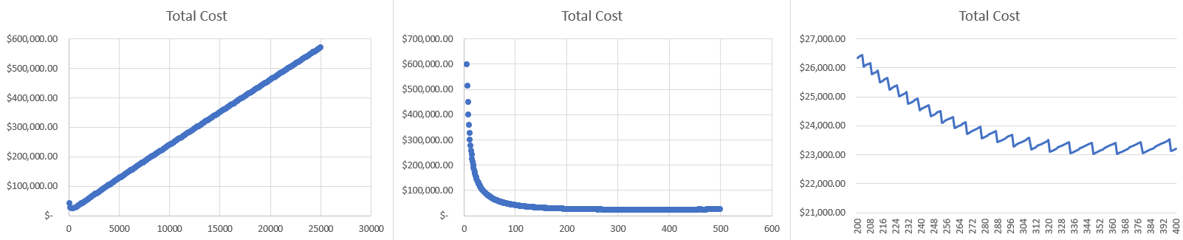

Next, we conducted what-if analysis using two-way tables in Excel. It is possible that our costs with suppliers could change since we cannot control other businesses. By using the following table, we can see how the total cost changes when we change the unit cost and/or the order cost in our model. Currently our optimized cost of $23,020.04 is shown in black with our current unit cost of $135 and order cost of $430. If we keep all other values in our model the same, but decrease or increase the unit cost or order cost, then our total cost would decrease in green or increase in red depending on the combinations.

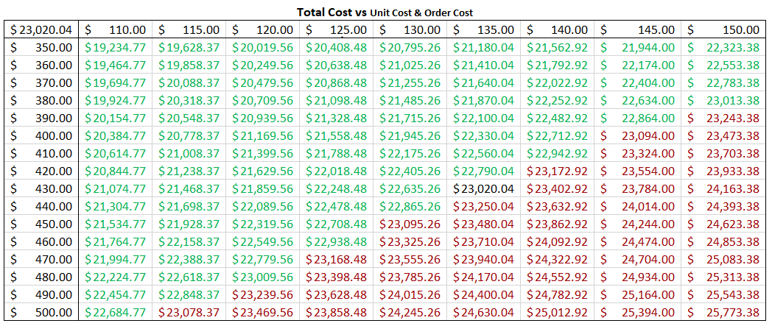

All of the previous analysis assumed the yearly demand to be 25,000 units. However, demand is much more likely to fluctuate. We ran 1,000 simulations of a demand with a triangle distribution that has a minimum of 23,000, a maximum of 27,000, and a mode of 25,550. From all of our simulations, our minimum total cost averaged out to be $23,202.86. We created a confidence interval and are 95% confident that the true mean is between $23,188.43 and $23,205.11. Naturally, this is larger than our minimum total cost with a flat 25,000 yearly demand since our demand from our simulations as a peak of 25,550 so it would cost more to order and store more parts. We also created histogram of all of the minimum total costs from each simulation to see its distribution. As you can see in the histogram below, we seem to have almost a normal distribution. Our data does not seem to be skewed since our mean ($23,202.86) is almost identical to our median ($23,203.19).

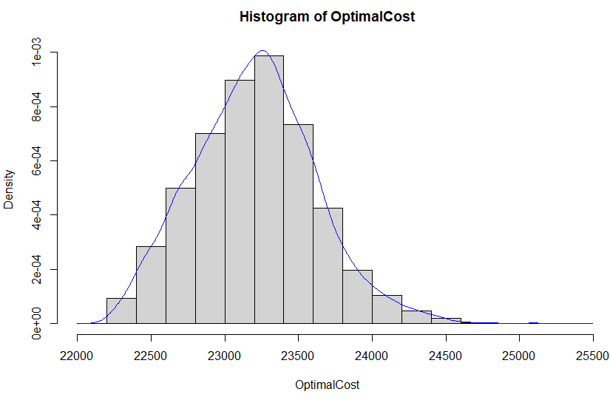

However, we can confirm that our optimal total costs are normally distributed by creating a Q-Q plot. The following plot shows that most total costs follow the normal red line except for some outliers. Since there seem to be an even amount of small and large outliers, they evened each other out when we calculated the mean and median. Even though it is not a perfect fit, we would still consider the data ‘normal’ and that a normal distribution fits the data.

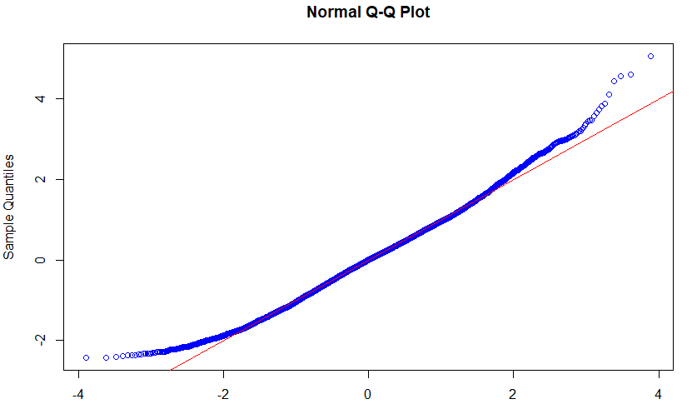

Next, we plotted the optimal inventory levels as well as the optimal order quantities. Based on our simulated demand, we seem to have a bimodal distribution of inventory levels and order quantities. The optimal inventory of 334 lead to our optimal cost of $23,202.86, however we do have a second optimal inventory level of almost 360 with a slightly larger optimal cost. The order quantity shows the exact same distribution, since the company plans to order 3 times the inventory level in order to make sure there are enough parts to meet demand.

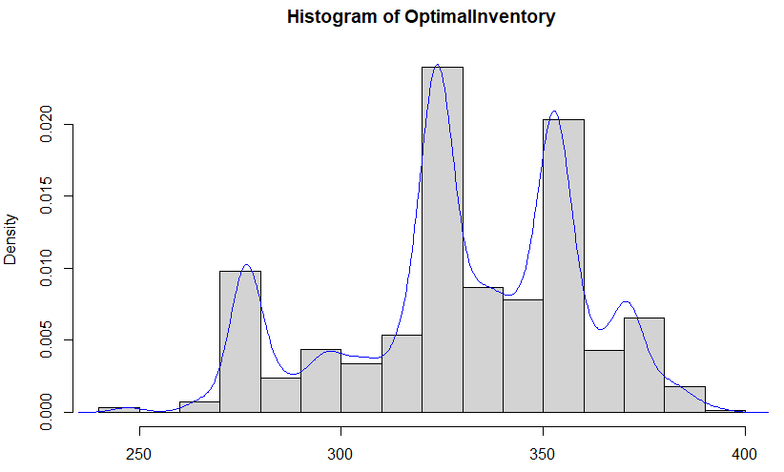

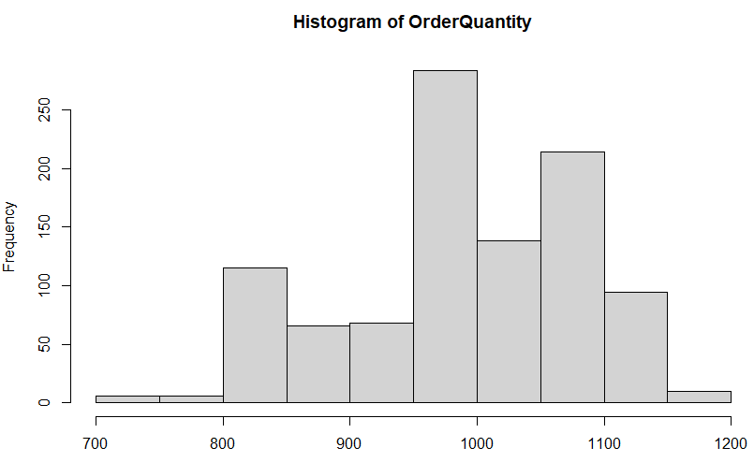

Lastly, we plotted the estimated number of annual orders from each simulation (rounded up to the next order amount). Since there are a lot of parts in each order but each order only represents an additional $430, we can see a consolidation of annual order amounts between 23 and 26. Order amounts have a much smaller effect on total cost than inventory levels at these ranges so we are not surprised to see many different inventory levels and total costs be from the same annual order amount. The annual order amounts are not normally distributed since there is a significantly smaller range of potential order amounts. Since there are peaks at 23, 24, 26, and 29, we would say this distribution is multimodal.

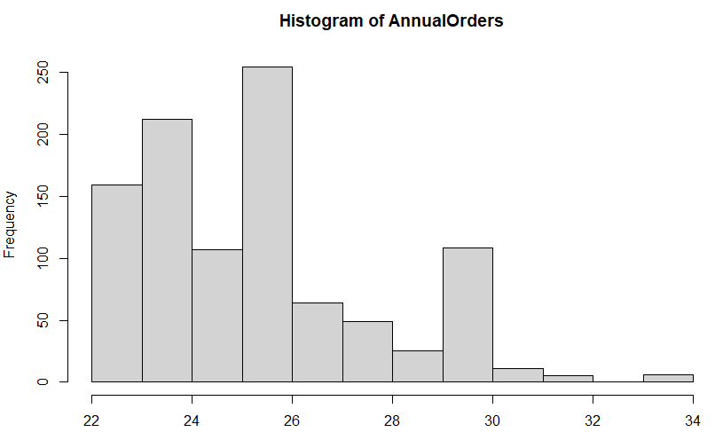

Summary

Based on our analysis, we would first recommend to the Vice President of Operations to spend time and resources identifying and predicting demand. There was a noticeable difference in total cost between our two demand scenarios. For phase two, we would recommend working with suppliers to lower the unit cost or order cost. Many suppliers offer discounts to customers for order frequency. Since there are similar costs between certain inventory levels, such as the 379 unit inventory level being only $25 more expensive annually than the 363 or 348 levels, it is possible the supplier could give a discount at that level since you would be adding an additional one or two orders per year and giving them more business.

If all of the costs remain constant and the company is extremely confident that yearly demand will be 25,000 units, we would recommend an inventory re-order level of 363 with 23 annual orders since it is technically the cheapest option. However with our variable demand scenario, an inventory level of 334 most frequently lead to the cheapest total cost based on our simulations.